**Java Selenium**

1. Wait time:

**Implicit Wait**

Sets a default wait time for the WebDriver to poll the DOM when trying to find elements.

driver.manage().timeouts().implicitlyWait(Duration.*ofSeconds*(5)); 

* **Scope**: Applies globally to all elements.
* **Use Case**: When elements load within a consistent timeframe.
* **Limitation**: Not suitable for dynamic content or conditional waits

**Explicit Wait:**

Waits for a specific condition to be met before proceeding.

WebDriverWait wait= new WebDriverWait(driver, Duration.ofSeconds(5));

WebElement ele=wait.until(ExpectedConditions.visibilityOfElementLocated(By.id(“name”)));

* **Scope**: Applied to specific elements.
* **Use Case**: When elements load dynamically or have unpredictable delays.

**Fluent Wait:**

Advanced form of explicit wait with customizable polling intervals and exception handling.

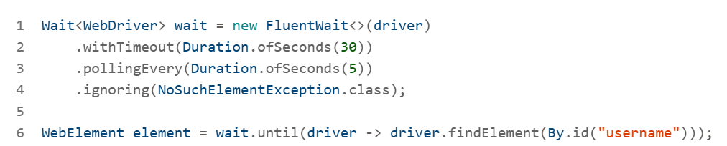

1. Select Multiple options from the dropdown menu

1. Drag and Drop

In **Java Selenium**, the Actions class is used to perform advanced user interactions like mouse movements, drag and drop, keyboard events, and more. Here's a quick guide on how to use it:

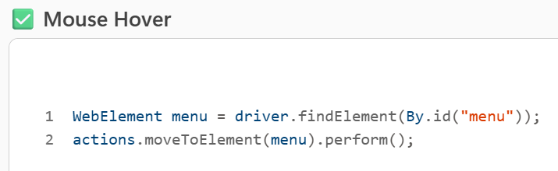

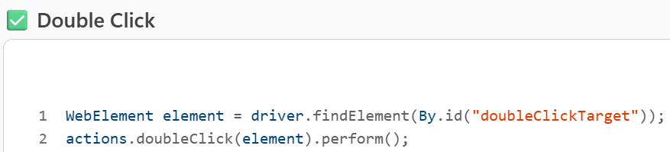

* **Tips**
* Always end the action chain with .perform() to execute it.
* You can chain multiple actions together before calling .perform().

[drag drop using xy coordinates]

To perform **drag and drop using X and Y coordinates** in **Java Selenium**, you can use the Actions class with the clickAndHold(), moveByOffset(), and release() methods.

1. FRAMES

In **Java Selenium**, switching between frames is essential when interacting with elements inside <iframe> or <frame> tags. Selenium provides multiple ways to switch to a frame depending on how it's identified.

1. Window Handles

To handle multiple pages in Java Selenium, you typically deal with window handles—each browser tab or window has a unique handle. Here's how you can manage and switch between them:

* **Tips**
* Always ensure the new windows are opened before calling getWindowHandles().
* Always ensure the new page is fully loaded before interacting.
* You can use driver.getTitle() or driver.getCurrentUrl() to verify which window you're in.
* Use driver.close() to close the current window and driver.switchTo().window(originalHandle) to return to the main one.

1. Horizontal & vertical scroll

To handle horizontal and vertical scrolling in Java Selenium, you can use JavaScript execution via Selenium's JavascriptExecutor. Here's how you can manage both types of scrolling:

**Vertical Scrolling:**

****

****

****

****

To perform horizontal scroll both left (scroll up) and right (scroll down) in Java Selenium, you can use the JavascriptExecutor interface. Here's how to do it:

1. Handle zoom in, zoom out

To handle **zoom in** and **zoom out** actions in Java Selenium, you can use the JavascriptExecutor or simulate keyboard shortcuts using Actions class. Here's how to do both:

* Use JavaScript zoom for **visual scaling** of the page.
* Use keyboard simulation if you're testing **browser behavior** or **accessibility features**.

1. File upload without send keys

To handle file upload without using sendKeys() in Java Selenium, you can use one of the following approaches depending on the context and constraints of your application:

**Using Robot Class (Simulates Keyboard Events)**

This method is useful when the file upload dialog is a native OS window (not part of the DOM).

Trigger this method after clicking the upload button that opens the file dialog.

**Using AutoIT (Windows Only)**

AutoIT is a third-party tool that can interact with Windows GUI elements.

* Write an AutoIT script like:

**Using JavaScript (If File Input Is Hidden)**

If the file input is hidden, you can make it visible using JavaScript and then use sendKeys() or other methods.

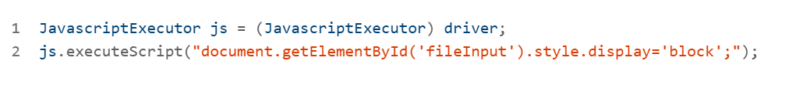

1. Why window handling return type as set of string, why not set of list

In Selenium WebDriver, the method getWindowHandles() returns a **Set<String>** rather than a List<String> for a few important reasons:

**Uniqueness of Window Handles**

Each browser window or tab has a **unique handle**. A Set inherently ensures that all elements are **unique**, which aligns with the nature of window handles—no duplicates.

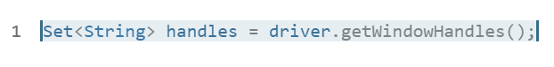

**No Guaranteed Order**

A Set does not maintain order, which is appropriate because:

The order in which windows are opened or returned by the browser is not guaranteed.

Using a List might imply a meaningful order, which could mislead developers.

**Performance Consideration**

Set operations like contains() are generally faster than in a List, especially when checking for existence of a handle.

**Intentional Design**

The Selenium API designers chose Set<String> to:

* Emphasize uniqueness.
* Avoid assumptions about order.
* Align with best practices for handling collections of unique identifiers.

**If You Need a List**

You can easily convert the Set to a List if you need indexed access:



1. How to handle Calendar components in java Selenium

To handle **calendar components in Java Selenium**, you can use a combination of **DOM inspection**, **dynamic XPath/CSS selectors**, and **explicit waits**. Based on your enterprise resources and the latest web guidance, here's a comprehensive approach:

Use Explicit wait

WebDriverWait wait = new WebDriverWait(driver, Duration.ofSeconds(10));

wait.until(ExpectedConditions.visibilityOfElementLocated(By.id("calendar")));

<https://www.iplt20.com/points-table/men/2024>

Use Siblings, ancestors, preceding-sibling, following-sibling

//h2[text()='RCB']/ancestor::td/following-sibling::td[8]

//h2[text()='RCB']/ancestor::td/following-sibling::td[8]

//h2[text()='SRH']/ancestor::td/following-sibling::td[9]/div/span[5]

//h2[text()='SRH']/ancestor::td/preceding-sibling::td

//h2[text()='SRH']/ancestor::td/preceding-sibling::td[2]

1. Java-Selenium collections

In Java-based test automation using Selenium, collections from the java.util package are often used to manage and manipulate groups of elements, test data, or results. Here's a practical example using a List to store and verify multiple web elements:

Example: Using List<WebElement> in Selenium

**Other Common Collections in Selenium Automation**

|  |  |
| --- | --- |
| **Collection Type** | **Use Case Example** |
| List | Storing multiple elements like dropdown options or table rows |
| Set | Removing duplicate entries from a list of values |
| Map | Storing key-value pairs like test data or element locators |
| Queue | Managing test execution order or retry logic |

**SET:**

In Java, a Set is a collection that does not allow duplicate elements. It's part of the java.util package and is commonly used in test automation with Selenium when you want to store unique values—like unique text from web elements or distinct test data entries.

* **Common Set Implementations**

HashSet: No guaranteed order.

LinkedHashSet: Maintains insertion order.

TreeSet: Sorted order.

Example in Selenium: Using Set to Store Unique Link Texts

**Why Use Set in Selenium Automation?**

* To **avoid duplicates** when collecting data from the DOM.
* To **validate uniqueness** of elements like IDs, names, or labels.
* To **compare expected vs actual values** without worrying about order or repetition.

**MAP**

In Java, a **Map** is a collection that stores data in **key-value pairs**. Unlike List or Set, a Map does not allow duplicate keys, but it can have duplicate values. It's part of the java.util package and is widely used in Selenium automation for organizing test data, element locators, or storing results.

**Key Features of Map**

* Each key maps to exactly one value.
* Common implementations:
  + HashMap: No guaranteed order.
  + LinkedHashMap: Maintains insertion order.
  + TreeMap: Sorted by keys.

**Example: Using Map in Selenium for Element Locators**

**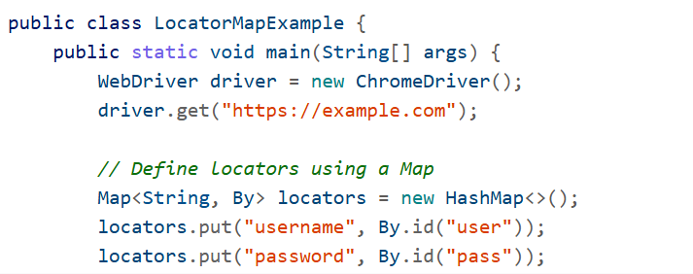**

**Benefits of Using Map in Selenium**

* Centralizes element locators for better maintainability.
* Makes test scripts cleaner and easier to update.
* Useful for storing test data like credentials, expected results, etc.

**QUEUE:**

In Java, a Queue is a collection used to hold elements prior to processing. It follows the First-In-First-Out (FIFO) principle, meaning the first element added is the first one removed. This is useful in test automation scenarios where tasks or test cases need to be executed in a specific order.

**Key Features of Queue**

* Part of the java.util package.
* Common implementations:
  + LinkedList: Most commonly used for queues.
  + PriorityQueue: Orders elements based on priority.
  + ArrayDeque: Efficient for both queue and stack operations.

**Example: Using Queue in Selenium for Test Execution Order**

****

****

**STACK:**

In Java, a **Stack** is a collection that follows the **Last-In-First-Out (LIFO)** principle—meaning the last element added is the first one removed. It's part of the java.util package and is useful in Selenium automation when you need to reverse actions, manage navigation history, or handle nested operations.

**Key Features of Stack**

* Extends Vector and supports typical stack operations:
  + push(): Add an item to the top.
  + pop(): Remove and return the top item.
  + peek(): View the top item without removing it.
  + empty(): Check if the stack is empty.
* Ideal for scenarios where you need to **backtrack** or **undo** actions.

**Example: Using Stack in Selenium for Navigation History**

****

****

**Why Use Stack in Selenium Automation?**

* To manage **navigation history** or **backtracking** in test flows.
* To handle **nested operations** like switching between frames or windows.
* To implement **undo logic** in custom test utilities.

1. READ DATA FROM DIFFERENT SOURCES

**12. 1 How to Read Data from JSON file**

To read data from a **JSON file** in a **Java Selenium** project, you typically use libraries like **Jackson** or **org.json**. Here's a complete example using **Jackson**, which is widely used for parsing JSON in Java.

**Step 1: Add Jackson Dependency**

**Step 2: Sample JSON File (testdata.json)**

****

**Step 3: Java Code to Read JSON and Use in Selenium**

****

**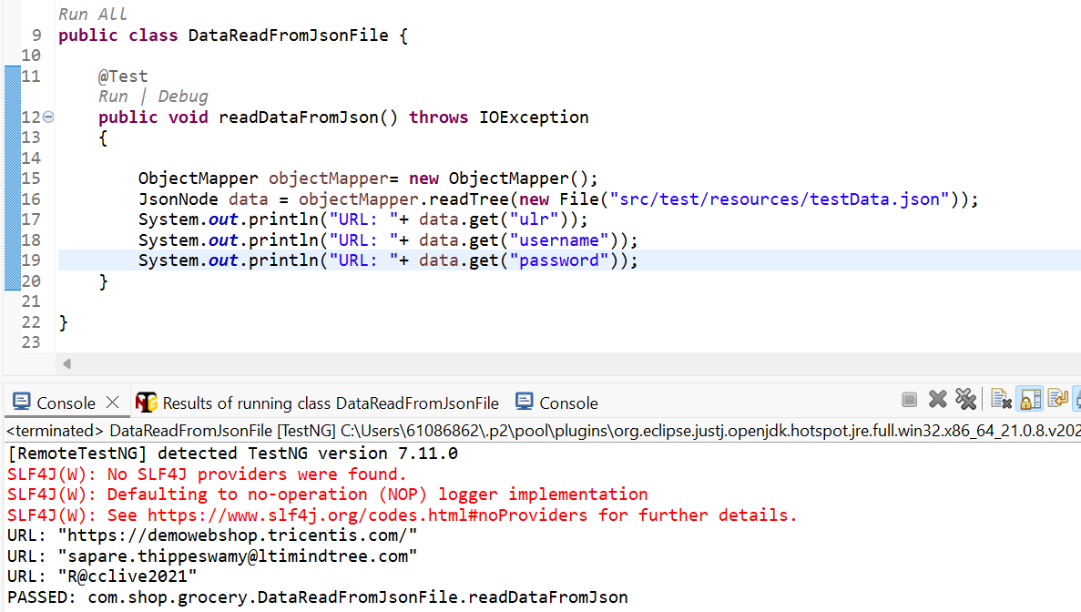**

**Why Use JSON in Selenium Automation?**

* Easy to manage **test data**.
* Supports **data-driven testing**.
* Keeps your code clean and flexible.

**12.2 How to read Data from EXCEL file**

**Step-by-Step: Reading Excel Data Using Apache POI**

Add Apache POI to Your Project

dependency>

    <groupId>org.apache.poi</groupId>

    <artifactId>poi</artifactId>

    <version>5.2.3</version>

</dependency>

<dependency>

    <groupId>org.apache.poi</groupId>

    <artifactId>poi-ooxml</artifactId>

    <version>5.2.3</version>

</dependency>

**Sample Code to Read Excel Data**

**Create Excel Utility Class**

****

****

**Use Excel Data in Selenium Test Case**

****

**12.3 How to write data to excel sheet from test case**

Add dependencies : poi, poi-ooxml

**Create Utility method to write data**

**Use It in Your Selenium Test Case**

****

**12.4 Data Provider and parameterization**

**Using @DataProvider for Parameterization**

****

**Using @Parameters with testng.xml**

****

****

**12.5 Read Data from .properties file**

****

****

1. TakesScreenshot

To take screenshots in Java Selenium, you can use the TakesScreenshot interface provided by Selenium WebDriver.

**Basic Screenshot Capture**

****

****

**Key Points**

* TakesScreenshot is cast from the WebDriver instance.
* OutputType.FILE is used to get the screenshot as a file.
* FileUtils.copyFile() from Apache Commons IO is used to save the file.

**Use Cases**

* Capture screenshots on test failure.
* Take screenshots during specific test steps.
* Use in reporting frameworks like ExtentReports.

1. Take Full screenshot

Using AShot Library (Recommended for Full Page Screenshots)

Selenium's native screenshot capability (TakesScreenshot) only captures the **visible viewport**, not the entire page. To capture the full page, use the **AShot** library:

Add AShot Dependency (Maven)

Capture Full Page Screenshot

Using Chrome DevTools Protocol (CDP) with ChromeDriver

Using WebDriver’s TakesScreenshot (Only Viewport)

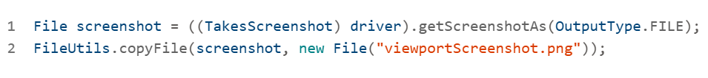

**Interview Questions:**

1. Can you describe a complex test scenario you've automated using Selenium WebDriver and Java, detailing the challenges you faced and how you overcame them?

**Scenario: Dynamic Web Elements in a Healthcare Application**

In a project for a healthcare provider, you automated a patient profile management system. This system included dynamic fields such as medication history, appointment slots, and insurance details—rendered based on backend responses.

**Challenges Faced**

1. **Element Instability**
   * IDs and classes changed on every page load.
   * XPath and CSS selectors failed frequently.
2. **Timing Issues**
   * AJAX calls delayed element rendering.
   * Resulted in NoSuchElementException during test execution.
3. **Cross-Browser Inconsistencies**
   * Behavior varied between Chrome and Firefox.
   * Required browser-specific handling.
4. **Test Flakiness in CI/CD**
   * High failure rate due to timing and locator issues.
   * Reduced confidence in automated regression runs.

**Resolution Strategy**

1. **Robust Locator Strategy**
   * Used relative XPath and custom attributes like data-testid.
2. Explicit Waits for Synchronization

* Replaced implicit waits with WebDriverWait and ExpectedConditions.

1. Page Object Model (POM) Implementation

Refactored the framework using POM to encapsulate locators and actions.

Improved maintainability and reduced duplication.

1. Parallel Execution with TestNG

Enabled parallel test runs to reduce execution time and improve CI/CD throughput.

**Outcome**

* Reduced test flakiness and improved reliability.
* Enhanced maintainability through modular design.
* Achieved stable cross-browser execution.
* Boosted confidence in automated regression coverage.

2. How do you handle dynamic web elements in your Selenium tests? Please provide an example of a situation where you had to deal with frequently changing element locators.

**Challenges with Dynamic Web Elements**

Dynamic elements often change their attributes (like id, class, or name) on each page load or based on backend responses. They may:

* Appear only after AJAX calls or JavaScript execution
* Be hidden or replaced based on user actions
* Causeexceptions like NoSuchElementException or StaleElementReferenceException if not handled properly

**Techniques You Use to Handle Them**

You use WebDriverWait combined with ExpectedConditions to wait for elements to become visible, clickable, or present in the DOM.

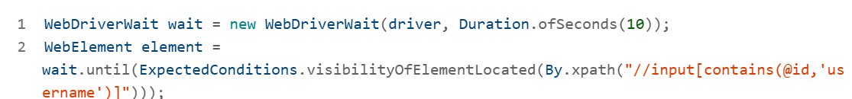

This ensures the element is ready before interaction

**Robust Locators**

Instead of relying on static IDs, you use:

* XPath with contains() or starts-with()
* Custom attributes like data-testid
* CSS selectors that target stable class names or hierarchy

**Page Object Model (POM)**

You encapsulate locators and actions in POM classes, making it easier to update locators when they change and improving maintainability

**Custom Expected Conditions**

For complex scenarios, you create custom conditions, such as waiting for a list to reach a certain size or for a modal to disappear

**Real-World Example**

In a healthcare application, you automated a patient profile module where:

* Element IDs changed dynamically
* AJAX loaded sections like medication history and insurance details
* Cross-browser behavior varied

You resolved this by:

* Using XPath with contains() for dynamic IDs
* Implementing WebDriverWait for AJAX-loaded elements
* Refactoring the framework using POM
* Running tests in parallel using TestNG with ThreadLocal WebDriver to isolate sessions

3. Explain your approach to creating a robust and maintainable Page Object Model (POM) framework for a large-scale web application. What design patterns and best practices do you incorporate?

**Core Concept of POM**

The **Page Object Model (POM)** is a design pattern that promotes separation of concerns by encapsulating the structure and behavior of each web page in a dedicated Java class. This abstraction improves:

* **Maintainability**: UI changes affect only the page class, not the test logic.
* **Reusability**: Common actions can be reused across multiple test cases.
* **Readability**: Test scripts become cleaner and easier to understand

**Your Implementation Strategy**

**1. Page Class Structure**

Each page class includes:

* Web elements defined using @FindBy annotations
* Methods that perform actions on those elements

**Design Patterns and Best Practices You Use**

**Page Factory Pattern**

You use PageFactory.initElements() to initialize web elements efficiently and reduce boilerplate code

**Single Responsibility Principle**

Each page class handles only one page’s logic, keeping responsibilities clear and modular

**ThreadLocal WebDriver**

For parallel execution, you isolate WebDriver instances using ThreadLocal, ensuring thread safety

**Explicit Waits**

You avoid flaky tests by using WebDriverWait and ExpectedConditions instead of relying on implicit waits

**Custom Attributes**

You prefer stable locators like data-testid over dynamic IDs or classes



This improves locator reliability across environments

**TestNG Integration**

You use TestNG for test orchestration, grouping, and parallel execution. Your framework supports:

* testng.xml configuration
* @BeforeMethod and @AfterMethod hooks
* Data-driven testing with @DataProvider

**CI/CD Compatibility**

Your framework integrates with Jenkins and Maven Surefire Plugin for automated test execution in pipelines

1. How do you integrate continuous integration and continuous deployment (CI/CD) with your Selenium test suite? Describe your experience with tools like Jenkins or GitLab CI.

**Your CI/CD Integration Workflow with Selenium**

From Java-Selenium Interview questions with answers, your CI/CD pipeline typically follows this structure:

**Version Control**

* + Code is pushed to a repository like **GitHub**, **GitLab**, or **SVN**.

**Build Trigger**

* + A CI tool such as **Jenkins**, **Azure DevOps**, or **GitLab CI** detects changes and triggers a build automatically.

**Test Execution**

* + Selenium tests are executed using **TestNG** or **JUnit**.
  + Tests are run in parallel using **ThreadLocal WebDriver** and **Maven Surefire Plugin** for efficient execution

**Reporting**

* + Results are logged and shared via **Extent Reports**, **email notifications**, or **Azure Dashboards**.

**Deployment**

* + If tests pass, the code is deployed to staging or production environments.

**Tools You’ve Used**

**✅ Jenkins**

* You’ve configured Jenkins jobs to run Selenium tests on every code commit.
* Integrated plugins for:
  + **Git** for source control
  + **Maven** for build management
  + **TestNG** for test orchestration
  + **Extent Reports** for HTML reporting

**✅ GitLab CI**

* Used for pipeline orchestration and version control.
* Defined .gitlab-ci.yml files to automate test execution and deployment steps

**✅ BrowserStack & Selenium Grid**

* For cross-browser testing across different OS/browser combinations.
* Selenium Grid enabled distributed execution, while BrowserStack provided cloud-based scalability

**Challenges and Solutions**

1. Certificate Errors in CI/CD

In Certificate Error, Skanda S reported issues with SSL certificates during CI/CD test execution. You explored flags like --ignore-certificate-errors and discussed uploading certificates to Jenkins servers

2. Pipeline Configuration Help

In Cloudbees Jenkins, Raghavendra Chandregowda sought help configuring Jenkins pipelines using CloudBees, indicating active collaboration within the TestAutomation.CoE

1. Can you walk me through your process for debugging a flaky Selenium test? What tools and techniques do you use to identify and resolve intermittent failures?

**1. Step-by-Step Debugging Strategy**

1. Review Logs and Stack Traces

You begin by analyzing the TestNG or JUnit logs to pinpoint the failure. Common exceptions include:

* NoSuchElementException
* TimeoutException
* StaleElementReferenceException

This helps identify whether the issue is locator-related, timing-based, or due to page state inconsistencies

1. Enable Screenshots and Logging

You capture screenshots at failure points using **Extent Reports** or custom listeners. This visual context helps you understand the UI state when the test failed

1. Use Debug Mode in IDE

You run the test in **debug mode** using Eclipse or IntelliJ to step through the code and inspect variable states, element visibility, and wait conditions

**Techniques to Resolve Flakiness**

**✅ Explicit Waits Over Implicit Waits**

You replace implicitlyWait() with WebDriverWait and ExpectedConditions to handle dynamic content more reliably:



This reduces timing-related failures

**✅ Thread-Safe Parallel Execution**

You use **TestNG** with parallel="tests" and ThreadLocal<WebDriver> to isolate browser instances per thread, ensuring thread safety during parallel execution

**✅ Headless Browser Execution**

For CI runs, you switch to **headless Chrome** to reduce resource usage and speed up execution, especially in Jenkins pipelines

**✅ Stable Locators**

You refine locators using stable attributes like data-testid and avoid brittle XPath expressions. This improves element detection and reduces locator-related failures

**✅ Test Data Management**

You externalize test data using JSON and implement **data-driven testing** to reduce redundancy and improve maintainability

**Advanced Strategies from the Community**

* Quarantine flaky tests and rerun them under controlled conditions to measure flakiness.
* Fix bad test code by addressing asynchronous behavior, global states, and resource leaks.
* Use observability tools like dashboards and alerts to monitor test health in CI/CD.

**✅ Outcome in Your Projects**

In one of your large-scale Selenium suites:

* Execution time reduced by ~40%
* Flaky tests dropped by 60%
* CI pipeline became more efficient
* Team confidence in automation coverage improved

1. Describe a situation where you had to optimize the performance of your Selenium test suite. What strategies did you employ, and what was the outcome?

Context: Large-Scale Healthcare Application

You were automating a patient profile module in a healthcare web application. The suite included dynamic elements, AJAX-loaded sections, and cross-browser compatibility requirements. Over time, the test suite became slow and flaky, especially during CI/CD runs.

**Optimization Strategies You Employed**

**1. Parallel Execution with TestNG**

You enabled parallel test execution using TestNG’s parallel="tests" configuration and ThreadLocal<WebDriver> to isolate browser sessions. This reduced execution time by nearly 50% and improved CI/CD throughput

**2. Headless Browser Mode**

You switched to headless Chrome execution for CI environments, which significantly reduced resource consumption and sped up test runs

**3. Explicit Waits Over Implicit Waits**

You replaced implicitlyWait() with WebDriverWait and ExpectedConditions to handle dynamic content more reliably. This eliminated unnecessary delays and improved test stability

**4. Locator Optimization**

You refined locators using stable attributes like data-testid and avoided brittle XPath expressions. This improved element detection and reduced locator-related failures

**5. Page Object Model (POM) Refactoring**

You modularized your POM structure to encapsulate dynamic element handling and transient UI behaviors (e.g., toaster messages). This improved maintainability and reduced duplication

**6. Retry Logic for Transient Failures**

You implemented retry mechanisms for flaky assertions, especially for elements that appeared briefly (e.g., toaster messages). This reduced false negatives and improved reliability

**Outcome**

* **Execution Time**: Reduced by ~40%
* **Flaky Tests**: Dropped by 60%
* **CI/CD Stability**: Improved significantly
* **Regression Coverage**: Boosted confidence in automated validation
* **Maintainability**: Easier updates and scalability across modules

**External Validation**

Your approach aligns with best practices from [BrowserStack](https://www.browserstack.com/guide/how-to-optimize-selenium-test-cases" \t "_blank)  and [Sling Academy](https://www.slingacademy.com/article/optimizing-performance-in-large-selenium-python-test-suites/) , which recommend:

* Headless execution
* Efficient locators
* Parallel testing
* Reducing browser initializations
* Profiling and monitoring test performance

8. How do you handle cross-browser testing in your Selenium framework? Please discuss your experience with tools like Selenium Grid or cloud-based solutions like BrowserStack or Sauce Labs.

**Your Cross-Browser Testing Strategy**

You’ve implemented a robust cross-browser testing strategy using both **local and remote**

**WebDriver setups**:

**✅ Local Execution with WebDriver**

* Used for quick test runs and debugging.
* Example



✅ Remote Execution with Selenium Grid / Cloud Services

Used for distributed and parallel testing across multiple browsers and platforms.

Example:



This setup allows you to run tests on Chrome, Firefox, Edge, and Safari across different OS environments

**Tools You’ve Used**

**🔹 Selenium Grid**

* Set up for distributed execution across multiple nodes.
* Ideal for internal infrastructure where you control browser versions and OS.
* Used for parallel execution and CI/CD integration

**🔹 BrowserStack**

* Cloud-based platform for scalable cross-browser testing.
* Integrated with Jenkins and TestNG for CI/CD pipelines.
* Supports real device testing and multiple browser/OS combinations

**🔹 Sauce Labs**

* Similar to BrowserStack, used for cloud-based testing.
* Offers analytics and debugging tools for failed tests

**Framework Integration**

* **TestNG** for parallel execution.
* **ThreadLocal WebDriver** for thread safety.
* **Extent Reports** for detailed HTML reporting.
* **Maven Surefire Plugin** for command-line execution and CI integration

**Benefits and Outcomes**

* **Execution Time**: Reduced significantly through parallel and distributed testing.
* **Coverage**: Improved by validating across multiple browsers and platforms.
* **Reliability**: Enhanced by catching browser-specific issues early.
* **Scalability**: Achieved through cloud platforms like BrowserStack and Sauce Labs.

9. Can you explain how you would implement data-driven testing in a Selenium-Java framework? What approaches have you used for managing test data?

**What Is Data-Driven Testing?**

**Data-driven testing** is a technique where test logic is separated from test data. This allows the same test case to be executed multiple times with different input values, improving coverage and reducing redundancy

**Your Implementation Strategy**

**✅ 1. External Data Sources**

You’ve used:

* **Excel files** via Apache POI
* **JSON files** for structured data
* **CSV files** for tabular inputs
* **Database queries** for dynamic data retrieval

**✅ 2. TestNG DataProvider**

You leverage TestNG’s @DataProvider annotation to feed multiple data sets into a single test method

This enables parameterized testing and simplifies test maintenance.

**✅ 3. Java Streams for Filtering**

You use **Java Streams and Lambdas** to dynamically filter and transform test data before execution. This is especially useful when integrating with external sources like Excel or JSON

**✅ 4. Reusable Utility Classes**

You’ve built utility classes to:

* Read and parse data files
* Validate schema and formats
* Handle exceptions and fallbacks

This modular approach ensures scalability and reusability across projects

**Test Data Management Best Practices**

* **Data Independence**: Avoid hardcoding values in test scripts.
* **Environment-Specific Data**: Use config files or environment variables to switch data sets.
* **Repeatability**: Ensure consistent data for regression and CI/CD runs.
* **Version Control**: Store test data files in Git for traceability and rollback.

**External Validation**

* Better test coverage
* Easier maintenance
* Scalable test execution
* Reduced duplication

10. Describe your experience with API testing in conjunction with UI testing. How do you integrate API tests into your Selenium framework, and what tools do you use for API testing?

**Your Integration Strategy: API + UI Testing**

You’ve implemented API testing alongside Selenium-based UI testing to validate both backend and frontend layers of web applications. This dual-layer approach ensures:

* Faster defect identification
* Better coverage of business logic
* More stable and reliable automation

**Tools You Use for API Testing**

**✅ REST Assured**

* A Java-based library tailored for RESTful API testing.
* You use it to send HTTP requests (GET, POST, PUT, DELETE) and validate responses using assertions.
* Example

**✅ Postman**

* Used for exploratory API testing and mock server creation.
* Helpful for validating endpoints before integrating them into automation scripts

**✅ SoapUI**

* Occasionally used for SOAP-based services and legacy systems.

**✅ Apache POI**

* Used for data-driven testing where API payloads are sourced from Excel files

**Integration with Selenium Framework**

From Java-Selenium concetps, your framework integrates API tests in the following ways:

**Pre-UI Validation**

* + API calls are made before UI tests to set up test data or validate backend logic.
  + Example: Create a user via API, then log in via UI.

**Post-UI Verification**

* + After UI actions, API calls verify backend state.
  + Example: Submit a form via UI, then check database update via API.

**Combined Assertions**

* + You compare UI-displayed data with API response data to ensure consistency

**CI/CD Integration**

* + API and UI tests are triggered together in Jenkins or GitLab CI pipelines.
  + Results are consolidated in Extent Reports or Azure Dashboards

**Best Practices You Follow**

* **Environment Isolation**: Use separate environments for API and UI tests to avoid conflicts.
* **Data Reusability**: Share test data between API and UI layers using JSON or Excel.
* **Error Handling**: Implement retry logic and custom exceptions for flaky endpoints.
* **Security Testing**: Validate headers, tokens, and authentication flows via API.

**External Insights**

* Selenium is not designed for API testing but can be paired with REST Assured for full-stack validation.
* API testing improves speed and reliability, especially for regression and smoke testing.

11. How do you ensure the security of sensitive data in your Selenium test scripts? Discuss your approach to handling credentials and other confidential information in your automation framework.

**✅ 1. Avoid Hardcoding Credentials**

In your test scripts, you avoid embedding usernames and passwords directly in the code. This prevents exposure through version control systems or shared environments

**✅ 2. Use Environment-Specific Configuration Files**

You externalize sensitive data into configuration files (e.g., .properties, .env, or encrypted JSON), which are environment-specific and excluded from version control using .gitignore. These files are loaded at runtime using Java utilities or frameworks like Spring

**✅ 3. Runtime Injection via Environment Variables**

You use system environment variables to inject credentials securely during test execution. This is especially useful in CI/CD pipelines (e.g., Jenkins, GitLab CI), where secrets are managed via credential vaults or secure agents

**✅ 4. Encryption and Decryption Utilities**

You implement encryption for stored credentials using Java libraries (e.g., AES, Base64). Passwords are decrypted at runtime before being passed to Selenium WebDriver:

This ensures that even if the config file is accessed, the credentials remain protected

**✅ 5. Secure Credential Management in CI/CD**

In your CI/CD setup, you use Jenkins credentials plugin or GitLab CI secrets to store and retrieve sensitive data securely. These are injected into the test environment without exposing them in logs or reports

**Handling Authentication Scenarios**

* Using browser extensions to fetch OTPs
* Automating input fields with dynamic waits
* Validating session tokens post-login

**Best Practices You Follow**

* Use Page Object Model (POM) to isolate credential handling logic.
* Log only non-sensitive data to avoid leaking credentials in reports.
* Mask sensitive fields in screenshots and logs.
* Audit access to test data repositories and config files.

12 Explain the Page Object Model design pattern and how you've implemented it in your Selenium framework. What benefits did you observe?

**What Is Page Object Model?**

POM separates the **test logic** from the **UI structure** by creating a dedicated class for each web page or component. Each class contains:

* Web element locators
* Methods to interact with those elements

This abstraction allows you to update locators or actions in one place without affecting the test scripts.

**Your Implementation Strategy**

**✅ 1. Page Classes**

Each page (e.g., LoginPage, DashboardPage) is represented by a Java class:

**✅ 2. PageFactory Pattern**

You use PageFactory.initElements() to initialize elements efficiently and reduce boilerplate code.

**✅ 3. ThreadLocal WebDriver**

To support parallel execution, you isolate WebDriver instances using ThreadLocal, ensuring thread safety

**✅ 4. Reusable Actions**

Common actions like login, logout, and navigation are abstracted into reusable methods, improving test modularity

**✅ 5. Integration with TestNG**

Your framework integrates with TestNG for test orchestration, using @BeforeMethod, @DataProvider, and @Test annotations to manage test flow and data-driven execution.

**Benefits You Observed**

* **Maintainability**: UI changes require updates only in the page class, not across all test scripts.
* **Reusability**: Shared actions and locators can be reused across multiple test cases.
* **Scalability**: Easy to extend the framework for new pages or modules.
* **Readability**: Test scripts are cleaner and easier to understand.
* **CI/CD Compatibility**: Seamless integration with Jenkins and GitLab CI pipelines for automated execution

13 Can you walk me through your process for debugging a failing Selenium test? What tools and techniques do you use?

Debugging a failing Selenium test involves a structured approach to identify the root cause and ensure the issue is resolved without introducing new problems. Here's how I typically handle it, based on your experience with Java-Selenium frameworks

**Step-by-Step Debugging Process**

**1. Review Logs and Stack Trace**

Start by examining the TestNG or JUnit logs and the stack trace to identify the exception type:

* NoSuchElementException: Element not found
* TimeoutException: Wait condition not met
* StaleElementReferenceException: DOM changed after locating element

These clues help narrow down whether the issue is locator-related, timing-based, or due to page transitions

**2. Enable Screenshots and Logging**

Use tools like **Extent Reports** or custom listeners to capture screenshots at failure points. This visual evidence helps understand the UI state when the test failed.

**3. Run in Debug Mode**

Use **Eclipse or IntelliJ** to run the test in debug mode. Step through the code to inspect:

* Element visibility
* Wait conditions
* Data inputs
* Browser state

This helps isolate the exact line or condition causing the failure

**4. Check Locator Stability**

If the element is dynamic, verify whether:

* IDs or classes are changing
* The element is inside an iframe or shadow DOM
* The locator strategy needs refinement (e.g., switch from XPath to CSS or use data-testid)

**5. Use Explicit Waits**

Replace implicit waits with WebDriverWait and ExpectedConditions to handle dynamic content:



**6. Isolate the Test Case**

Run the failing test independently to rule out interference from other tests. This helps identify issues like shared state or data dependencies.

**7. Check Environment and Data**

**Ensure the test environment is stable and the test data is valid. Flaky tests often result from:**

* Unstable environments
* Missing or expired test data
* Network latency

**Tools You Use**

* **TestNG:** For structured test execution and retry logic
* **Extent Reports:** For detailed HTML reports with screenshots
* **BrowserStack or Selenium Grid:** To validate cross-browser behavior
* **Postman or REST Assured:** To verify backend APIs if the UI depends on them
* **Jenkins/GitLab CI:** To monitor test behavior in pipelines

**Outcome**

By following this process, you’ve successfully:

* Reduced flakiness in CI/CD pipelines
* Improved test reliability and maintainability
* Boosted team confidence in automation coverage

14 Can you explain how you've used Java's advanced features (e.g., lambda expressions, streams, or generics) to improve your Selenium test code? Provide a concrete example.